- August  Buisness Spotlight  N Stuff Music Remodel to Expand, Enhance Offerings  A Blawnox fixture for decades, N Stuff Music is marking its 50th anniversary by updating and expanding its iconic music establishment. A full-service music store, N Stuff Music specializes in instruments, lessons, rental, service and sound system installation. They recently purchased the residence next door to modernize and grow its lesson capability. “The Little Lesson House” features 10 individual, sound-proof lesson rooms and comfortable waiting areas for musicians of all ages and skill levels. The opposite side of the main building, previously apartments and storage, is currently being converted to a performance area for students and bands, group lessons and clinics. “Next Door” also will feature a small café for patrons to relax and enjoy live music. The new areas, as well as the exterior of all three buildings, have been updated with a new fresh look and feel.  If you’re interested in having your business spotlighted, please email blxoffice@blawnox.net for more information | Blawnox Borough News  Police Department Changes  We would like to welcome Patrick Goodman as our new police chief! He has worked in the Blawnox Police Department for more than 21 years. Along with a new chief, the borough is also getting a new full-time officer, Nick Hawk, and we are in the process of hiring new part time officers to welcome into our community.  On July 31, both Chief Bucha and Officer Cawley retired after a combined 99 years of service. The borough hosted a last shift celebration, with food and people stopping by with well wishes. Thanks to all who donated! Each officer was celebrated with an official last call. Thanks again for Chief Bucha and Officer Cawley’s service and for all who made the day special.  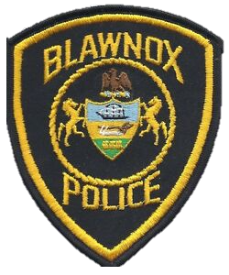
- Contact Us  Company Name  Blawnox Borough  Street Address  376 Freeport Rd.  City, ST Zip Code  Pittsburgh, PA 15238  Phone  412-828-4141  Email  blxoffice@blawnox.net  Website  www.blawnox.com  Be sure to check out our new and improved website. | Important Information  The Borough Office will be closed on Labor Day, September 2nd.  Trash will be picked up the following day, September 3rd.  Attention Dog Owners:  August 5-21st , Allegheny County will be distributing rabies vaccine baits in parks especially. These are not harmful to your dog; however, they may get an upset stomach if they eat too many so please make sure they are on a leash. For more info: http://www.achd.net/racoon/  Please see the attached notice regarding Blawnox Borough’s public water system.  Blawnox Borough Council  Debbie Laskey, President  Randy Stoddard, Vice President  John Simmons  Meghan Kennedy  Katie Coban  Jessica Dayhoff  Elaine Palmer  Anthony Gross, Mayor  Gordon Taylor, Engineer  Jack Cambest, Solicitor  Mallori McDowell, Code Enforcement

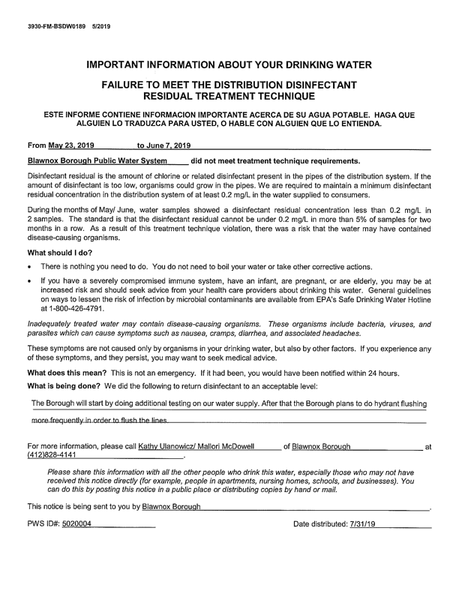
Lawnox
orough
PRSRT STD
ECRWSS
U.S. POSTAGE
PAID
EDDM Retail
LOCAL
POSTAL CUSTOMER

