- March/ April 2020  REAL ID is Coming  Beginning October 1, 2020 a REAL ID or passport will be required to board a commercial flight or visit a secure federal facility. Visit www.dmv.pa.gov/REALID for more information.  Pennsylvania Primary Voting  Primary Voting in Pennsylvania will be held on April 28th, 2020. The Borough of Blawnox votes at the Senior High Rise at 701 Center Avenue. If you need an absentee Ballot or Mail in Ballot the applications can be found on the Borough Website.  If you’re interested in having your business spotlighted, please email blxoffice@blawnox.net for more information | Blawnox Borough News  Borough Offices Closed to the Public  The Borough of Blawnox Offices are closed to the Public until further notice. Payments can still be dropped off in the drop box located to the right of the front door. Please call 412-828-4141 or email blxoffice@blawnox.net with any questions or concerns.  Blawnox Community Park Closed  The Blawnox Community Park is closed until further notice out of an abundance of caution for the community.  Emergency Notification Test  Our Emergency Notification system SwiftReach is set up and ready for use. The Borough will be sending a test notification on the afternoon of March 23rd, 2020. If you have not yet given the Borough your contact information and would like to receive emergency notifications please call the borough office at 412-828-4141 or email blxoffice@blawnox.net.  Looking for a Junior Council Person  Blawnox Borough Council is looking for a high school student from the Borough to apply to fill the Junior Council Person Position. This position requires attendance at council meetings and allows the student to get a firsthand view of how local government runs. For more information contact the Borough at 412-828-4141 or email blxoffice@blawnox.net.
Easter Egg Hunt  The Blawnox Easter Egg Hunt has been Canceled out of an abundance of caution for our community members. Please look for information about a fun event for children later this year at Bestofblawnox.com.  Free Shredding Event  Guardian Storage, located at 1390 Old Freeport Road is offering a free shredding event on April 9, 2020 from 11 am – 2 pm.  Save the Date  The Community Wide Yard Sale will be held Saturday June 20th, 2020. Keep an eye out for more information to come.  Important Information  The Borough Office will be closed on Good Friday April 10th, 2020. | Adopt-A-Block Program  As a part of Earth Day, we are planning a year long initiative entitled Adopt-a-Block. Adopt-a-Block encourages you to improve your neighborhood by cleaning littered curbs, sidewalks, and vacant lots; removing signs from utility poles and reporting graffiti. Take part in this exciting initiative by “adopting” your block for 2020. From business districts to your own block, this community effort will benefit our community in more ways than one! When litter is dropped on city streets the rain can wash it into storm drains, creating expensive repairs and damaging our eco-system. This is not just a beautification issue! By adopting a block, a person, or group of neighbors, or business commits to cleaning up their block for the next year. To help with your commitment to the quality of life within your community, we will provide supplies and support to aid in the beautification of your neighborhood. If you are interested in adopting a block, please contact Diane at 412-828-2218.  Borough Taxes  The Borough of Blawnox property tax bills will be mailed soon. As a reminder we have a new tax collector for 2020, Casey Cunningham. There will be no office hours for tax collection until further notice. Payments should be mailed to the tax collector. When tax office hours resume, they will be Tuesdays during the discount period from 11:30 am – 1:30 pm at 351 Walnut St. and then from 1:30 pm – 3:30 pm at the Borough Office. Please check the borough website for updates on when tax office hours may resume.

Earth Day Cleanup
This years Earth Day Cleanup has been postponed. Please continue to check the Borough Website for more information on a rescheduled date.

- Contact Us  Company Name  Blawnox Borough  Street Address  376 Freeport Rd.  City, ST Zip Code  Pittsburgh, PA 15238  Phone  412-828-4141  Email  blxoffice@blawnox.net  Website  www.blawnox.com  Be sure to check out our new and improved website!  Blawnox Borough Council  Debbie Laskey, President  Randy Stoddard, Vice President  John Simmons, Council Member  Meghan Kennedy, Council Member  Katie Coban, Council Member  Jessica Dayhoff, Council Member  Elaine Palmer, Council Member  Anthony Gross, Mayor  Kathy Ulanowicz, Borough Manager  Gordon Taylor, Engineer  Jack Cambest, Solicitor  Mallori McDowell, Assistant Manager Jeff Armstrong, Code Enforcement | 2019 Budget Expenditures  Below is a chart showing the breakdown of the Boroughs Budget for 2019.  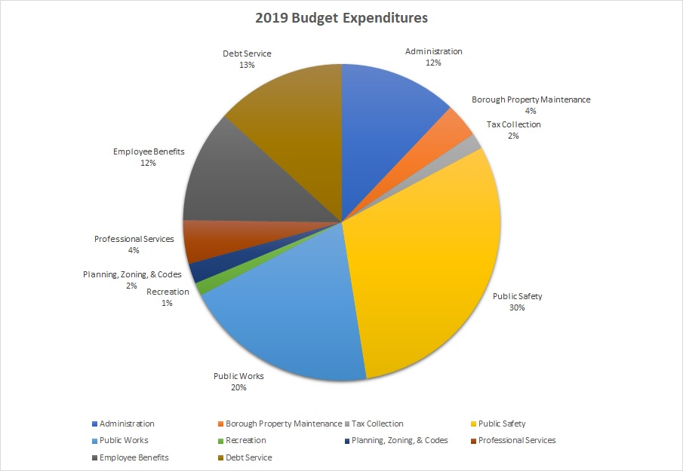  Sewer Expenditures from 2016 - 2020  Blawnox Borough administration has received many questions lately about how the money from $45 line fee on your sewer bills is spent. Below is a chart of the expenditures for sewer line repairs since 2016:  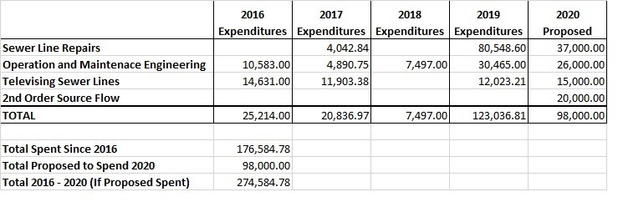  Blawnox Baseball Association  Registration is now open for Blawnox Baseball and Softball. For more information and to sign up please go to www.blawnoxbaseball.org.
Lawnox
orough
PRSRT STD
ECRWSS
U.S. POSTAGE
PAID
EDDM Retail
LOCAL
POSTAL CUSTOMER

