- May/  - June 2022  Borough Offices Open by Appointment Only  The Borough of Blawnox Offices are open by appointment only and masks are required to enter the building.  Newsletter Insert Available for Your Events  If you are having an event, please let the Borough know so that we can add it to our newsletter insert for you. We would love to share what you are doing with the community.  Facebook Page  Be sure to check out our new Facebook page www.facebook.com/blawnoxborough | Blawnox Borough News  Memorial Day 2022  The Blawnox Borough Memorial Day Parade will take place on Monday May 30, 2022 at 10:30 am. The parade will start at the Sunoco Station on Freeport Road and end at the Blawnox Veterans Memorial on the corner of Freeport Road and North Avenue. There will be a special service at the Monument at the conclusion of the parade. A picnic lunch, catered by Hello Party Service, will be held at the Blawnox Community Park immediately following. Kids are encouraged to decorate their bikes and join in the parade. Any groups or veterans interested in participating in the parade should contact kcoban@blawnox.net.  Water Meter Reads  The Borough is asking for some water customers to read their meters because we are unable to read the meter electronically. The Borough is working to replace these meters but due to supply chain issues we are unable to get the meters at this time. As soon as the meters become available, we will be making arrangements with these water customers to schedule the replacement. If you receive a courtesy hang tag, please promptly read your meter and return to the Borough office.  Pennsylvania Primary Elections  Pennsylvania will be holding its primary election on May 17th, 2022. Primary voting will occur at the Blawnox High Rise at 701 Center Avenue, Blawnox, PA 15238. The polls are open from 7:00 am until 8:00 pm.
Spring Is Here  Spring is here, which means the grass and weeds have started to grow. Don’t forget the Borough has an ordinance that grass, and weeds must not be more than six inches high. Please keep your grass and weeds cut! Don’t forget the weeds and grass along your sidewalks.  Clean Up After Your Dogs  Please be a courteous neighbor and help keep Blawnox a clean and safe community by cleaning up after your dogs.  Dumpster Pick Up Notice  Dumpsters in the Borough may only be picked up between 6:00 am and 9:00pm Monday through Saturday. | Thank You Volunteers!  Thank you to all of the Volunteers who came out for our Earth Day event Blawnox Cleans Up! We had about 25 volunteers who helped us collect around 150 bags of trash and debris from Freeport Road, Blawnox Community Park, the Blawnox Community Garden and the surrounding areas. Please help us continue to keep Blawnox Clean by keeping your sidewalks and yards clear of debris and weeds.  Township of O’Hara Flag Disposal Bin  The Township of O’Hara is pleased to announce its partnership with Etna American Legion Post 597 and Scout Pack 678 to install an American Flag Old Glory Flag Disposal Bin at the Municipal Building. The scouts will do a monthly inventory of the bin and properly retire the flags placed in the bin.  Free Food Distribution Event  North Hills Community Outreach will be hosting Free Food Distribution events at the Blawnox Borough Municipal Building at 376 Freeport Road, Pittsburgh, PA 15238. The events will be held May 20th, June 17th, July 15th, and August 19th from 2-3 pm. Everyone is welcome and no ID or proof of income is required. There will be fresh produce, packaged food, and meat products available. Questions please contact Kelly King at 412-487-6316 x3144 or kdking@nhco.org.

Important Information
The Blawnox Borough Offices will be closed May 30th for Memorial Day. Trash and Recycling will be delayed until Tuesday May 31st due to the holiday. The Borough Office will be closed for the Juneteenth Holiday on June 20th. Trash will still be collected on June 20th. The Borough Office will also be closed on July 4th. Trash will be delayed until Tuesday July 5th due to the holiday.
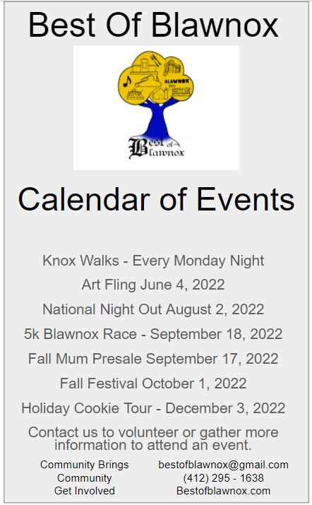
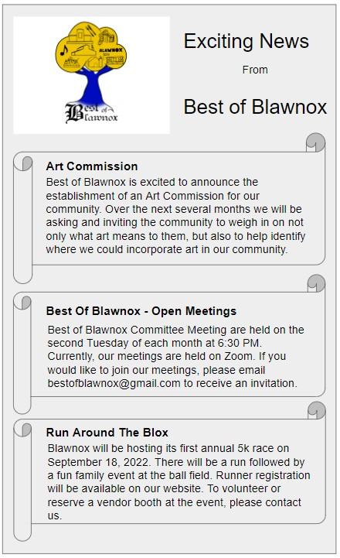
- Contact Us  Company Name  Blawnox Borough  Street Address  376 Freeport Rd.  Pittsburgh, PA 15238  Phone  412-828-4141  Email  blxoffice@blawnox.net  Website  www.blawnox.com  Facebook  www.facebook.com/blawnoxborough  Be sure to check out our new Facebook Page!  Blawnox Borough Council  Debbie Laskey, President  Randy Stoddard, Vice President  John Simmons, Council Member  Meghan Kennedy, Council Member  Katie Coban, Council Member  Jessica Dayhoff, Council Member  Elaine Palmer, Council Member  Anthony Gross, Mayor  Kathy Ulanowicz, Borough Manager  Gordon Taylor, Engineer  Jack Cambest, Solicitor  Mallori McDowell, Assistant Manager Jeff Armstrong, Code Enforcement | Blawnox Seeking Code Enforcement Officer  Blawnox Borough is looking to hire a part time Code Enforcement Officer. The job would be approximately 6 hours a week. The Code Enforcement Officer responsibilities include driving around to look for  violations in the community, sending violation notices, writing tickets or citations, and attending court hearings. Applicants must have a valid PA Driver License and their own vehicle. For more information, please contact the Borough Office at 412-828-4141.  A Message from Duquesne Light  Duquesne Light will recycle your old fridge or freezer for free. Have an old fridge or freezer you’re not using? They will pick it up and haul it away for free and pay you $50. In addition to your recycling incentive, if you purchased a new ENERGY STAR certified refrigerator or freezer after June 1, 2021, you can apply for an appliance rebate. Make sure you get yours! To schedule your pick up or apply for an appliance rebate, visit dlcwattchoices.com/appliancerecycling or call 1-800-257-2510.  Annual Water Quality Report  The Blawnox Public Water System is required annually to produce a Consumer Confidence Report about the quality of our water. This year’s report can be found at https://www.blawnox.com/sites/g/files/vyhlif2826/f/uploads/2021_consumer_confidence_report_final.pdf  LIHWAP  The Borough will be participating in the LIHWAP Assistance Program which is a temporary emergency grant program to help low-income families with overdue water bills. For more information visit: www.blawnox.com/sites/g/files/vyhlif2826/f/uploads/lihwap_flyer_hswa_2022.pdf  Blawnox Borough Public Water System  Blawnox Borough Public Water System has been working with the DEP to resolve some treatment technique violations that have occurred. Please know that there have been no issues with any of our bacteria samples and there is nothing you need to do at this time. The public notifications for the treatment technique violations can be found on our website https://www.blawnox.com/sites/g/files/vyhlif2826/f/uploads/november_december_treatment_technique_violation_public_notice.pdf.  Blawnox Borough Public Water System  Blawnox Borough Public Water System has been working with the DEP to resolve some treatment technique violations that have occurred. Please know that there have been no issues with any of our bacteria samples and there is nothing you need to do at this time. The public notifications for the treatment technique violations can be found on our website https://www.blawnox.com/sites/g/files/vyhlif2826/f/uploads/november_december_treatment_technique_violation_public_notice.pdf.  Blawnox Borough Public Water System  Blawnox Borough Public Water System has been working with the DEP to resolve some treatment technique violations that have occurred. Please know that there have been no issues with any of our bacteria samples and there is nothing you need to do at this time. The public notifications for the treatment technique violations can be found on our website https://www.blawnox.com/sites/g/files/vyhlif2826/f/uploads/november_december_treatment_technique_violation_public_notice.pdf.
Lawnox
orough
PRSRT STD
ECRWSS
U.S. POSTAGE
PAID
EDDM Retail
LOCAL
POSTAL CUSTOMER

