- November/ December 2019  Business Spotlight  Mike’s Custom Detailing  Our mission has been the same since 1996 – to provide old fashioned courteous service while going above and beyond each customer’s specific needs. Free pickup and delivery of your vehicle is available to the local area. Services range from a hand car wash to a complete detail. For more information call Mike at 412-826-9087 or stop by the shop located at 149 4th Street in Blawnox. You can also check out our webpage on Facebook or google us.  If you’re interested in having your business spotlighted, please email blxoffice@blawnox.net for more information | Blawnox Borough News  Night of the Lights  Please join us on Thursday December 5th at 6:30 p.m. for Blawnox Night of the Lights. Festivities will begin at the Monument with carols performed by the Dorseyville Middle School Chorus while we wait for Santa’s arrival. After Santa arrives please join us at the Hoboken Church for a photo with Santa and to enjoy some Cookies and Hot Cocoa. Additional activities will be available at the church including Mike the Balloon Guy.  Thank You!  Blawnox Police Department and Borough would like to thank the following people/ businesses for their generous support of our Halloween Festivities this year. Thanks to: Mulley’s Auto Repair, Tower Tire, Riverview Products, Pianos & Stuff, Blawnox Glenover Vol. Fire Company, Blawnox Auxiliary Police, Blawnox Sportsman Club, Athletic Association Club of Blawnox, Overbeck’s Nursery, Blawnox Industrial LLC, Tower Auto Sales, ABC Beverage, Howard Hanna, American Legion O’Hara Post 555, and the Hoboken Church.
Code Enforcement Officer  Blawnox Borough is looking to hire a part time Code Enforcement Officer. The job would be approximately 7 hours a week. The Code Enforcement Officer responsibilities include driving around to look for violations in the community, sending violation notices, writing tickets or citations, and attending court hearings. Applicants must have a valid PA Drivers License and their own vehicle. For more information please contact the Borough Office at 412-828-4141. | Q & A with the Borough  Q: Why are there no swings at the new playground?  A: In order to have swings in a playground a safety zone is required around the swing set. The total required area for a standard 8’ high 2 seat swing set is 24’ by 32’. The decision was made to utilize the space in a way that more children can have access to play at a time.  Q: Is the $45 line fee going away for 2020?  A: Unfortunately no. The amount generated by the line fee is a critical part of our sewer budget. The money collected for the line fee is used to pay for both sewage treatment and for repairs to the sewer lines. Borough Council is always looking at other ways to fund the required work and repairs to our manholes and lines, and still keep sewage treatment costs as low as possible for all customers. The Borough has budgeted $113,000 for work to our sewers in 2020 and we have to know we will have the funds to do that work.  Water Charges  The Borough of Blawnox gets many questions about the amount we charge for water. The following chart is a comparison of our water charges with other Water Authorities in the area.  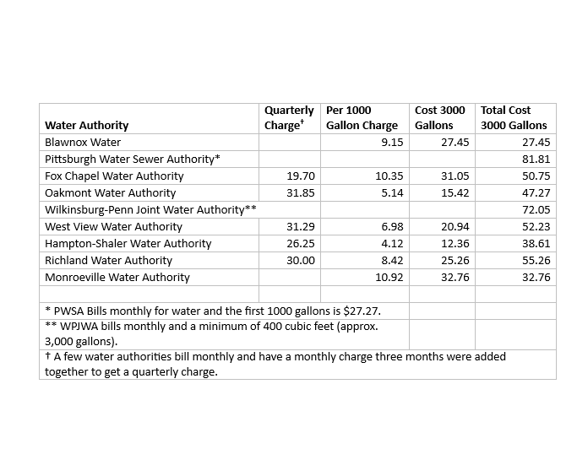

- Contact Us  Company Name  Blawnox Borough  Street Address  376 Freeport Rd.  City, ST Zip Code  Pittsburgh, PA 15238  Phone  412-828-4141  Email  blxoffice@blawnox.net  Website  www.blawnox.com  Be sure to check out our new and improved website!  Blawnox Borough Council  Debbie Laskey, President  Randy Stoddard, Vice President  John Simmons, Council Member  Meghan Kennedy, Council Member  Katie Coban, Council Member  Jessica Dayhoff, Council Member  Elaine Palmer, Council Member  Anthony Gross, Mayor  Kathy Ulanowicz, Acting Manager  Gordon Taylor, Engineer  Jack Cambest, Solicitor  Mallori McDowell, Code Enforcement | Blawnox Borough Trash Requirements  The Borough of Blawnox recently passed a Quality of Life Ordinance that allows for Tickets to be issued for some time sensitive code enforcement issue and because we are beginning to enforce this we wanted to remind residents of our trash requirements.  - Trash is every Monday and Recycling is every other Monday.  - Trash should not be placed at the curb earlier than 5:00 pm the day before and must be returned to the customer’s property no later than 9:00 pm on the day of pick-up.  - Trash needs to be put out in reusable containers made of durable, watertight, rust and corrosion resistant material, such as plastic, metal or fiberglass, and shall have a tight-fitting cover.  - No person should accumulate on any public or private property any garbage, rubbish, bulky waste, or any other municipal or residential solid waste.  ALCOSAN Clean Water Assistance Fund  ALCOSAN is once again offering assistance to homeowners in the service area who meet family income limits set by the government. The grant will give you a credit of $32 every three months. Social Service agencies across the region accept and process applications. To apply for our area an application can be done at Northern Area Multi – Service Center at 209 13th Street, Pittsburgh, PA 15215.  Important Information  The Borough Office will be closed on Thanksgiving Day November 28th, the day after Thanksgiving November 29th, Christmas Eve December 24th, Christmas Day December 25th and New Year’s Day, January 1st, 2020.
Lawnox
orough
PRSRT STD
ECRWSS
U.S. POSTAGE
PAID
EDDM Retail
LOCAL
POSTAL CUSTOMER

