- November/  - December 2022  Borough Offices Open by Appointment Only  The Borough of Blawnox Offices are open by appointment only and masks are required to enter the building.  Newsletter Insert Available for Your Events  If you are having an event, please let the Borough know so that we can add it to our newsletter insert for you. We would love to share what you are doing with the community.  If you’re interested in having your business spotlighted in our newsletter, please email blxoffice@blawnox.net for more information. | Blawnox Borough News  Night of the Lights  Night of the Lights Is Changing!  Date: SATURDAY, December 3, 2022  Time: 4:00 p.m. – 6:30 p.m.  See details on inside flyer  Thanksgiving Food Drive  Blawnox Borough will be hosting a food drive to help local families for the Thanksgiving Holiday. People who wish to donate gift cards, may drop them off at the Borough by November 16th. If you or someone you know are in need of a little help this holiday season, please contact the Borough Office at 412-828-4141.  Long Time Blawnox Resident Turning 100  Long time Blawnox resident George Bubash is turning 100 on December 30th. If you would like to send a card and wish him well, please deliver it to the Borough Office no later than 1:00 p.m. on Monday, December 19th.  Important Information  The Blawnox Borough Offices will be closed Thanksgiving November 24th, the Day After Thanksgiving November 25th, Christmas Day Observed December 26th, and New Year’s Day Observed January 2nd. Trash pick-up will not be delayed due to any of the holiday closures. December 26th will also be recycling.
Winter Is Coming  Winter is coming, which means snow and ice are a possibility. Don’t forget the Borough has an ordinance that sidewalks must be kept in a proper state of repair and maintained free from hazardous conditions. All snow and ice must be removed from sidewalks within 24 hours of snowfall ending.  Hazardous Waste Recycling  The Borough of Blawnox offers a hazardous waste recycling program to collect items like paint, electronics, motor oil and other similar items. To schedule a pickup call Waste Management’s Hazardous Waste at 1-800-449-7587. | Cash Bash 2022  The Aspinwall and Blawnox Fire Companies will be hosting a Cash Bash on Saturday, January 28, 2023 from 7:00-11:00pm at the Comfort Inn at 180 Gamma Drive in RIDC Industrial Park. Tickets are $20 and are available from Fire Department Members and at the Blawnox Borough Office.  Newman Plumbing Meter Replacement  The Borough received a grant to have Newman Plumbing replace some of the older water meters. The meters have finally arrived, and Newman Plumbing will be reaching out to the homeowners whose meters will be getting replaced to schedule an appointment. Someone will need to be home at the time of the water replacement.  Trash Reminder  As a reminder to all residents, your trash may not be put out before 5:00 pm the day before trash day and it must be put out in garbage cans with lids.  Visible Address Numbers  The Borough of Blawnox would like to remind all homeowners of the importance of having visible address numbers on your houses. Having a visible street address is a requirement of the International Property Maintenance Code which the Borough adopted in 2017. In addition, it is essential for first responders in case of an emergency. We would like to encourage homeowners to make sure you have visible address numbers and if not to fix the issue as soon as possible.  Dumpster Pick Up Notice  As a reminder for all property owners who have a dumpster for their trash service, dumpsters in the Borough may not be picked up before 6:00 a.m. Please make sure your dumpster provider is aware of this requirement.
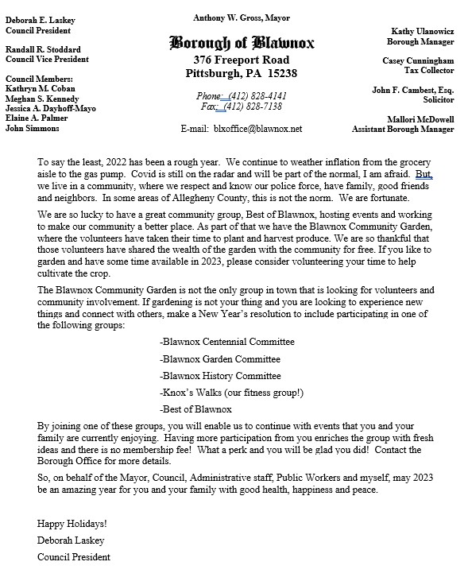

2022 Rates
The 2023 rates for water, sewer, and trash plus the tax millage will be set at the December Council Meeting. The tax millage for the Borough will raise in 2023 to 10.85, which is a one mil increase. Beginning January 1st, the water rate for 2023 will raise to $11.21/ 1000 gallons with a minimum use of 3000 gallons. This raise is in anticipation of a raise from PWSA. Trash will remain at a rate of $65 per quarter for 2023. The sewer rates will increase to $12.94/ 1000 gallons and the per bill fee will increase to $21.88. These rates reflect a direct pass through of the increases the Borough will be receiving from ALCOSAN for processing our sewage. The line fee will remain at $45 per quarter.
- Contact Us  Company Name  Blawnox Borough  Street Address  376 Freeport Rd.  Pittsburgh, PA 15238  Phone  412-828-4141  Email  blxoffice@blawnox.net  Website  www.blawnox.com  Facebook  www.facebook.com/blawnoxborough  Be sure to check out our new Facebook Page!  Blawnox Borough Council  Debbie Laskey, President  Randy Stoddard, Vice President  John Simmons, Council Member  Meghan Kennedy, Council Member  Katie Coban, Council Member  Jessica Dayhoff, Council Member  Elaine Palmer, Council Member  Anthony Gross, Mayor  Kathy Ulanowicz, Borough Manager  Gordon Taylor, Engineer  Jack Cambest, Solicitor  Mallori McDowell, Assistant Manager Jeff Armstrong, Code Enforcement | Halloween Thank You!  The Blawnox Police Department and Borough would like to thank the following people/ businesses for their generous support of our Halloween Festivities this year. Thanks to: Allegheny County District Attorney’s Office, Athletic Association Club of Blawnox, Black and Gold Distributing, Blawnox Auxiliary Police, Blawnox Glenover Volunteer Fire Company, Blawnox Industrial LLC, Hi-Tech Auto Care, Howard Hannah, Michel Landscaping Company, Nox’s Tavern & Grille, Old Thunder Brewing Company, Overbeck’s Nursery & Landscaping, Riverview Product Services Inc., and Tower Auto Sales Inc.  Blawnox Borough Public Water System  Blawnox Borough Public Water System has been working with the DEP to resolve some treatment technique violations that have occurred. Please know that there have been no issues with any of our bacteria samples and there is nothing you need to do at this time. The public notifications for the treatment technique violations can be found on our website https://www.blawnox.com/water-division/pages/public-notices-blawnox-borough-public-water-system.  Blawnox Borough Public Water System  Blawnox Borough Public Water System has been working with the DEP to resolve some treatment technique violations that have occurred. Please know that there have been no issues with any of our bacteria samples and there is nothing you need to do at this time. The public notifications for the treatment technique violations can be found on our website https://www.blawnox.com/sites/g/files/vyhlif2826/f/uploads/november_december_treatment_technique_violation_public_notice.pdf.  Blawnox Borough Public Water System  Blawnox Borough Public Water System has been working with the DEP to resolve some treatment technique violations that have occurred. Please know that there have been no issues with any of our bacteria samples and there is nothing you need to do at this time. The public notifications for the treatment technique violations can be found on our website https://www.blawnox.com/sites/g/files/vyhlif2826/f/uploads/november_december_treatment_technique_violation_public_notice.pdf.  Blawnox Borough Public Water System  Blawnox Borough Public Water System has been working with the DEP to resolve some treatment technique violations that have occurred. Please know that there have been no issues with any of our bacteria samples and there is nothing you need to do at this time. The public notifications for the treatment technique violations can be found on our website https://www.blawnox.com/sites/g/files/vyhlif2826/f/uploads/november_december_treatment_technique_violation_public_notice.pdf.
Lawnox
orough
PRSRT STD
ECRWSS
U.S. POSTAGE
PAID
EDDM Retail
LOCAL
POSTAL CUSTOMER

