- September/  - October 2022  Borough Offices Open by Appointment Only  The Borough of Blawnox Offices are open by appointment only and masks are required to enter the building.  Newsletter Insert Available for Your Events  If you are having an event, please let the Borough know so that we can add it to our newsletter insert for you. We would love to share what you are doing with the community.  If you’re interested in having your business spotlighted in our newsletter, please email blxoffice@blawnox.net for more information. | Blawnox Borough News  Halloween  The Borough of Blawnox will be holding Trick or Treating on Monday, October 31st from 6:00 – 8:00 p.m. This year marks the return of our Costume Parade for the kids. The parade line up will begin at 5:30 p.m. at the corner of Woodland Road and Freeport Road. The parade will finish at the Hoboken Church with a special treat.  National Thank a Police Officer Day  National Thank a Police Officer Day is Saturday, September 17th, 2022, make sure you stop and thank a police officer for protecting and serving our community!  Blawnox Centennial Celebration  Blawnox Borough will be celebrating its Centennial in 2025. The Centennial Committee is looking for volunteers to support the town we all love. Please contact: BlawnoxCentennialCommittee@gmail.com if you are interested. The Committee meets the 3rd Tuesday of each month at 6:00 p.m. at the Blawnox Borough Building.  Creating the Blawnox Centennial Book  As part of the Boroughs Centennial Celebration the Blawnox History Committee has secured Tom Powers to create a Centennial Book for the community. You may see Mr. Powers walking around, taking pictures, talking to residents, and visiting businesses. Mr. Powers will be wearing an ID so don’t be alarmed if you see him around the Community.
Fall Is Here  Fall is here, which means leaves falling from the trees. Don’t forget the Borough has an ordinance that sidewalks must be kept in a proper state of repair and maintained free from hazardous conditions. Please keep your sidewalks cleaned up and free from leaves and weeds.  Food Distribution  North Hills Community Outreach has extended their free food distribution at the Blawnox Municipal Building to include September 16th and October 21st.  Save the Date  Save December 1st, 2022 for the return of Night of the Lights! Stay tuned for more details on the event. | Emergency Notification System  If you would like to be on the Borough’s list to receive water and other emergency notifications, please contact the Borough Office at 412-828-4141 or email blxoffice@blawnox.net.  Pennsylvania Election Day  Pennsylvania will be holding its next election on November 8th, 2022. Blawnox Borough residents will be voting at the Blawnox Highrise at 701 Center Avenue, Pittsburgh, PA 15238. Voting opens at 7:00 a.m. and closes at 8:00 p.m.  Thanksgiving Food Drive  Blawnox Borough will be hosting a food drive to help local families for the Thanksgiving Holiday. People who wish to donate non-perishable food items or gift cards, may drop them off at the Borough by November 16th.  A Reminder from the Tax Collector  The Blawnox Borough Tax Collector is Casey Cunningham. If you need a copy of your receipt, lost your statement, or have any other questions about your taxes you can contact her at 412-499-2086 or email blawnoxtaxcollector@gmail.com.  A Reminder for Emailed Water Bills  Blawnox Borough would like to remind residents who receive email bills that if you do not see your bill when you expect it to make sure you check your Spam or Trash folder. We have had several reports lately of people not getting a bill but finding it in their Spam folder.

Important Information
The Blawnox Borough Offices will be closed Columbus Day October 10th, Veteran’s Day November 11th, Thanksgiving November 24th, and the Day After Thanksgiving November 25th. Trash pick-up will not be delayed due to any of the holiday closures.

Blawnox Seeking Code Enforcement Officer

Blawnox Borough is looking to hire a part time Code Enforcement Officer. The job would be approximately 6 hours a week. The Code Enforcement Officer responsibilities include driving around to look for violations in the community, sending violation notices, writing tickets or citations, and attending court hearings. Applicants must have a valid PA Driver License and their own vehicle. For more information, please contact the Borough Office at 412-828-4141.

- Contact Us  Company Name  Blawnox Borough  Street Address  376 Freeport Rd.  Pittsburgh, PA 15238  Phone  412-828-4141  Email  blxoffice@blawnox.net  Website  www.blawnox.com  Facebook  www.facebook.com/blawnoxborough  Be sure to check out our new Facebook Page!  Blawnox Borough Council  Debbie Laskey, President  Randy Stoddard, Vice President  John Simmons, Council Member  Meghan Kennedy, Council Member  Katie Coban, Council Member  Jessica Dayhoff, Council Member  Elaine Palmer, Council Member  Anthony Gross, Mayor  Kathy Ulanowicz, Borough Manager  Gordon Taylor, Engineer  Jack Cambest, Solicitor  Mallori McDowell, Assistant Manager Jeff Armstrong, Code Enforcement | Private Sewer Lateral Testing  Blawnox Borough discharges its sanitary sewage to the Allegheny County Sanitary Authority (ALCOSAN) treatment plant along the Ohio River. For many years, the ALCOSAN communities have been working together to reduce the amount of stormwater and groundwater infiltration into the ALCOSAN system to stop/mitigate sewer overflows in wet weather events. Borough Council, and their counterparts in the ALCOSAN basin, entered into an agreement with the Pennsylvania Department of Environmental Protection (DEP). One of the requirements of that agreement is for the Borough to mandate the testing of private sanitary sewer laterals at the time of property transfer to determine whether stormwater, surface water or other water sources are getting into the lateral. A plumber will need to camera the lateral and if it fails the inspection it will need to be repaired prior to sale.  Blawnox Borough Public Water System  Blawnox Borough Public Water System has been working with the DEP to resolve some treatment technique violations that have occurred. Please know that there have been no issues with any of our bacteria samples and there is nothing you need to do at this time. The public notifications for the treatment technique violations can be found on our website https://www.blawnox.com/sites/g/files/vyhlif2826/f/uploads/may_june_treatment_technique_violation.pdf.  Blawnox Borough Public Water System  Blawnox Borough Public Water System has been working with the DEP to resolve some treatment technique violations that have occurred. Please know that there have been no issues with any of our bacteria samples and there is nothing you need to do at this time. The public notifications for the treatment technique violations can be found on our website https://www.blawnox.com/sites/g/files/vyhlif2826/f/uploads/november_december_treatment_technique_violation_public_notice.pdf.  Blawnox Borough Public Water System  Blawnox Borough Public Water System has been working with the DEP to resolve some treatment technique violations that have occurred. Please know that there have been no issues with any of our bacteria samples and there is nothing you need to do at this time. The public notifications for the treatment technique violations can be found on our website https://www.blawnox.com/sites/g/files/vyhlif2826/f/uploads/november_december_treatment_technique_violation_public_notice.pdf.  Blawnox Borough Public Water System  Blawnox Borough Public Water System has been working with the DEP to resolve some treatment technique violations that have occurred. Please know that there have been no issues with any of our bacteria samples and there is nothing you need to do at this time. The public notifications for the treatment technique violations can be found on our website https://www.blawnox.com/sites/g/files/vyhlif2826/f/uploads/november_december_treatment_technique_violation_public_notice.pdf.
Lawnox
orough
PRSRT STD
ECRWSS
U.S. POSTAGE
PAID
EDDM Retail
LOCAL
POSTAL CUSTOMER

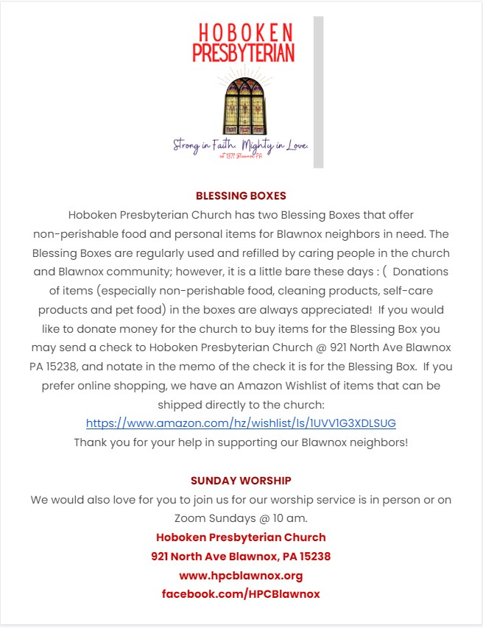

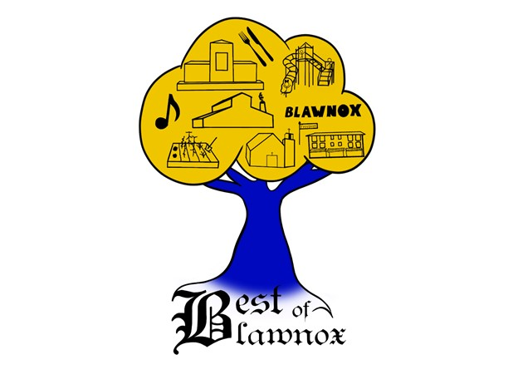 bestofblawnox@gmail.com
Best of Blawnox
Calendar of Events

Fall Mum Pickup – September 17, 2022
Fall Festival – October 1, 2022
Holiday Cookie Tour – December 3, 2022
Community Brings Community (412) 295-1638
Get Involved Bestofblawnox.com

National Night Out Thank You
The Best of Blawnox would like to thank everyone who participated and all who joined us for our National Night Out Event. A special thanks to Fox Chapel Area Adult Education for their participation.
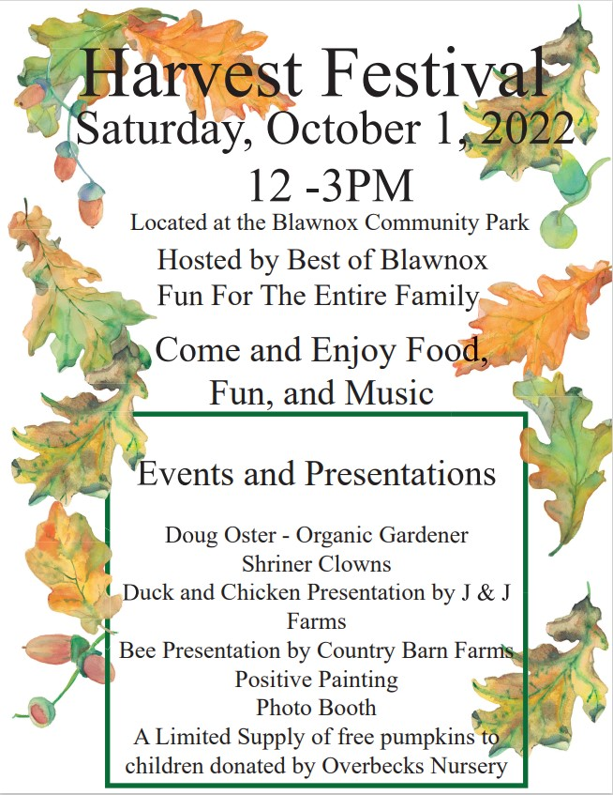

Fall Mum and Cornstalk Sale
The Best of Blawnox is doing a fall mum and cornstalk sale. There will be pink, orange, red, purple, and white mums. The mums must be pre ordered and pre-paid and will be available for pickup on October 1st at the Harvest Festival. To order or for information about sizes and pricing email bestofblawnox.com, go to Best of Blawnox Facebook, or call 412-295-1638.

